Purchase Options in AWS EC2 When to Use in Real Time
AWS provides different pricing / purchase options to run EC2 instances based on cost, duration, flexibility, and reliability.
To know which purchase option to select in AWS EC2, decide based on 3 main factors :
How long will it run?
Is traffic stable or variable?
Can it tolerate interruption?
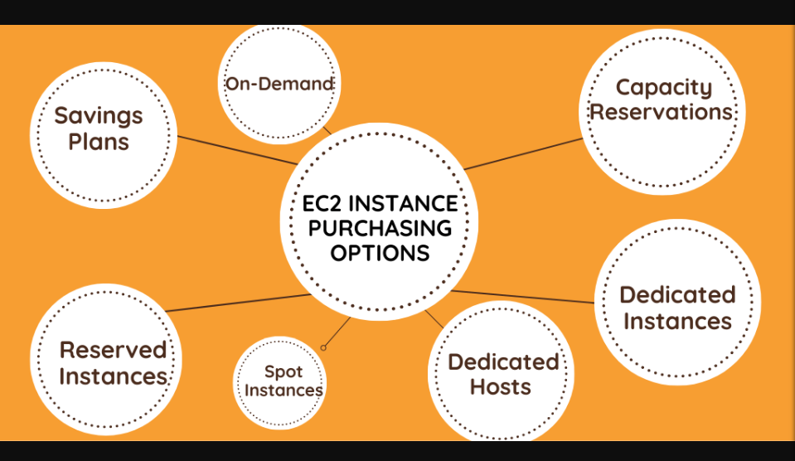

- On Demand Instances

Pay for compute capacity by the second or hour with no long-term commitment.

Cost: Highest price (pay per second/hour, no discount)

Features
- No upfront payment required
- No contract or commitment
- Flexible and scalable
- Easy to launch or terminate anytime
- Full control over instance configuration
When to use:
- You are testing an application.
- You have short-term projects.
- Traffic is unpredictable.
Real-time example:
A startup launches a new website and doesn’t know how many users will come. They use On-Demand so they can start and stop instances anytime and pay only for what they use.

- Reserved Instances (RI)

Reserve an instance for 1 year or 3 years for heavy discount.

Features
- Up to 72% cheaper than On-Demand
- Fixed capacity
- Long-term commitment

Types of Reserved Instances
- Standard RI – Fixed type, max discount
- Convertible RI – Change instance family, less discount

1. Standard RI
- Highest discount (up to 72%)
- Fixed instance type, region, OS
- Can’t change easily
- Best for steady workloads (DB, ERP, production app)

2. Convertible RI
- Lower discount (~54%)
- Can change instance family, OS, size
- Best if workload may change

Payment Options
Option | Meaning
No Upfront | Pay monthly, small discount
Partial Upfront | Pay some now, some monthly
All Upfront | Pay full now, max discount

Cost: Up to 70–75% cheaper than On-Demand (1 or 3 year commitment)
When to use:
- You have a stable workload running 24/7.
- You know the instance type and size in advance.
Real-time example:
A company’s ERP system runs all year without stopping. They buy Reserved Instances for 1 or 3 years to reduce cost.

- Savings Plans
Commit to a fixed hourly spend instead of fixed instance.

Cost: Similar discount to RI (up to 72%) but more flexible
When to use:
- You want long-term discount but with flexibility.
- You may change instance types or sizes.
- When you have steady workloads

Types of Savings Plans
- Compute Savings Plans
  - Applies to EC2, Fargate, and Lambda
  - Most flexible
  - Automatically applies to any instance type, region, or OS
  - Up to 66% savings
- EC2 Instance Savings Plans
  - Specific to an instance family in a region (e.g., m5 in ap-south-1)
  - Less flexible but more savings
  - Up to 72% savings
- SageMaker Savings Plans
  - For ML workloads on SageMaker
  - Lower cost for training and inference

Real-time example:
An e-commerce company commits to a certain monthly AWS spend, but scales up and down using different instance families during sales.

- Spot Instances

Spot Instances let you use unused EC2 capacity at up to 90% discount compared to On-Demand instances.

If AWS needs the capacity back, it can interrupt your instance with a 2-minute warning.

Cost: Cheapest – up to 90% discount

Key Features:
- Low cost: Save a lot compared to On-Demand
- Interruptible: AWS can reclaim the instance with 2 minutes notice
- Flexible: Can be used across instance types, regions, and AZs
When to use:
- Your application can handle interruptions.
- You want very low cost.
Real-time example:
A data science team runs machine learning training jobs. If the job stops, it can restart. So they use Spot Instances and save up to 90%.

- Dedicated Hosts

Dedicated Hosts are physical servers fully dedicated to a single customer. You get complete control over the underlying hardware.

Cost: Most expensive

Key Features:
- A whole physical server is allocated only to you
- You can bring your own licenses (BYOL) for software like Windows, SQL Server, Oracle
- Visibility into sockets, cores, and host ID
- You control instance placement on the host
When to use:
- You need physical server control.
- You have strict compliance or software licensing.
- Legacy enterprise applications
Real-time example:
A bank runs licensed software that requires a dedicated physical machine, so they use Dedicated Hosts.

- Dedicated Instances

Dedicated Instances run on hardware that is dedicated to a single customer, but unlike Dedicated Hosts, you don’t get visibility or control over the physical server.

Cost: Higher than On-Demand

Key Features:
- Instances run on single-tenant hardware
- Physically isolated from other AWS customers
- No control over sockets, cores, or host placement
- Managed fully by AWS
When to use:
- You want hardware isolation from other customers.
Real-time example:
A government project needs isolated infrastructure, so they choose Dedicated Instances.

Difference from Dedicated Hosts:
- Dedicated Hosts: Full control of physical server
- Dedicated Instances: Hardware is dedicated, but AWS manages it

Capacity Reservation
Capacity Reservations allow you to reserve a specific amount of compute capacity (EC2 instances) in a particular AZ (Availability Zone) for as long as you need. This ensures that when you launch an instance, capacity is available for you—even during peak demand.

Why Capacity Reservation?
Sometimes during:
- Black Friday
- Product launches
- Disaster recovery
- Sudden traffic spikes
EC2 may say: "Insufficient capacity"
Capacity Reservation avoids this by pre-booking capacity.

Key Features:
- Guaranteed capacity in a specific AZ
- Can be used with On-Demand or Reserved Instances
- You pay for reserved capacity even if not in use
- Helps meet compliance and regulatory requirements

When to Use:
- Launch critical workloads during peak periods
- Ensure high availability for production systems
- Combine with Dedicated Instances or Hosts for isolation

In One Line
- On-Demand → Flexible, short-term
- Reserved / Savings Plan → Long-term, cost saving
- Spot → Cheapest, interruptible
- Dedicated → Compliance & isolation
